**Confidence intervals on open economical data**

1. Construct a 90% confidence interval for difference of shares of mining production and water supply and treatment production with respect to the total volume of production. Can we be 90%confident that the difference of shares of mining production and water supply and treatment production is less than 3.5%? Use the data from January 2014 until October 2015.

By inserting the following script into R-program:

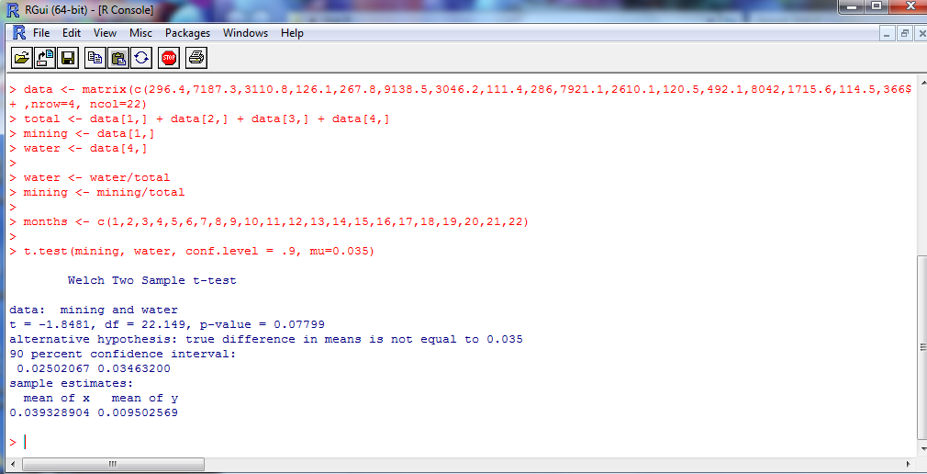

We get the 90% Confidence Interval for difference of shares of mining production and water supply with respect to the total volume of production:

**[ 0.02502067, 0.03463200]**

And when testing the following hypotheses:

- ≥ 0.035

- ≤ 0.035

We obtain the p-value = 0.07799 from R-program’s computations. However, via p-value we cannot determine whether to reject or fail to reject $H_{0}$. Therefore, we use the confidence interval to make a decision. Values of alternative hypothesis, that are ≤ 0.035, lie within the bounds of alternative hypothesis and outside of the null hypothesis. Thus, we reject $H_{0}$ and accept $H_{a}$ and can conclude that the difference in shares of water and mining productions is less than 0.035.

Through R-program we can also determine the normality of the mining and water shares with respect to the total volume of production.

For Shapiro-test of both mining and water, we get that they are distributed normally, because p-values are comparatively large.

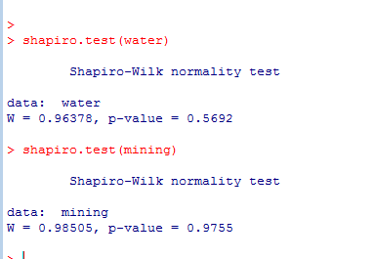

The graphs of mining and water ratios also support the normality test.

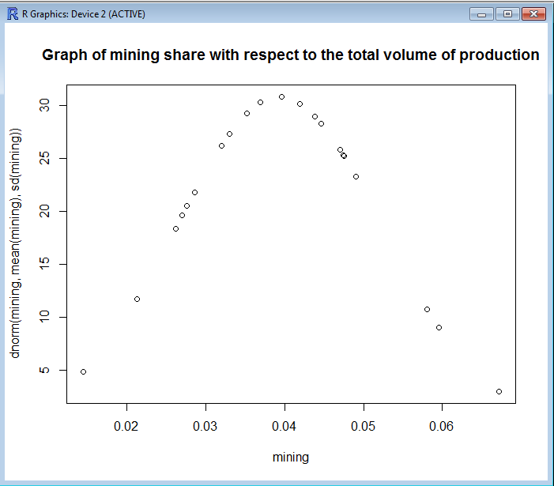

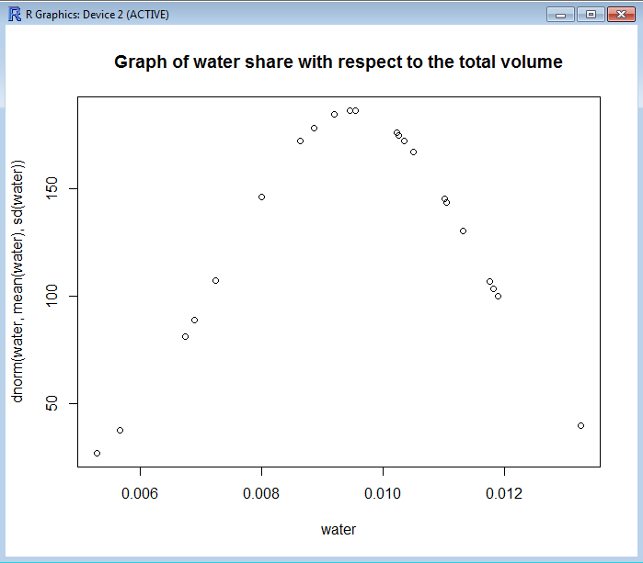

(Please see the file ‘Prob1.R’ for the script of the above graphs)

1. Using data about the industrial production volume by economic activity in Kyrgyzstan, is there sufficient evidence to conclude that the total share of manufacture and energy production is greater than 95% of the total volume of production? Use the data from January 2014 until October 2015.

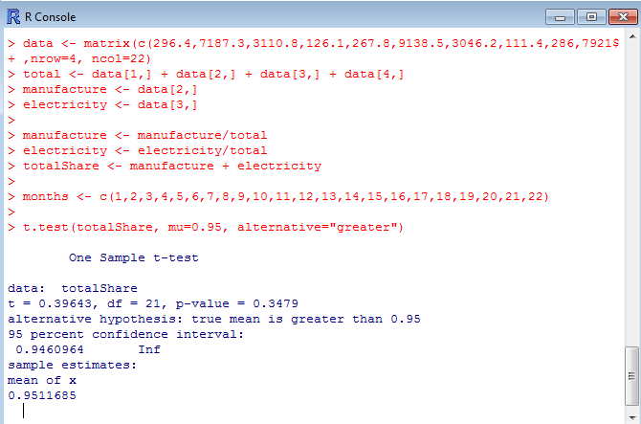

R-program computations allow us to conclude that the total share of manufacture and energy production is not greater than 95% of the total volume of production based on the p-value. Because p-value=0.3479 ≥ 0.1, we fail to reject $H_{0}:$ totalShare ≤ 0.95 and, therefore, cannot accept $H_{a}:$ totalShare ≥ 0.95.

1. Using data about the industrial production volume by economic activity in Kyrgyzstan, is there sufficient evidence to conclude that the share of manufacture production with respect to the total volume of production differs from the share of mining production by 73.5% at 5% significance level? Use the data from January 2014 until October 2015.

We test the following hypotheses in R-program:

- ≠0.735

- =0.735

Because p-value=2.2 $e^{-16}$ < 0.01 we strongly reject the $H_{0}:$ $μ_{m}$- $μ_{w}$ ≠0.735 and conclude that the share of manufacture production does not differ from share of mining production by 73.5%.

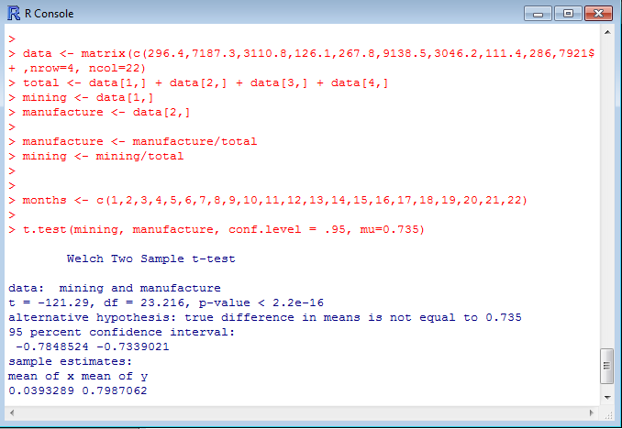

We can additionally test the normality of distribution of manufacture production and plot the normal graph (for mining the graph is done above). Because p-value=0.2404 > 0.1, we assume the distribution to be normal and can see it in the graph below:

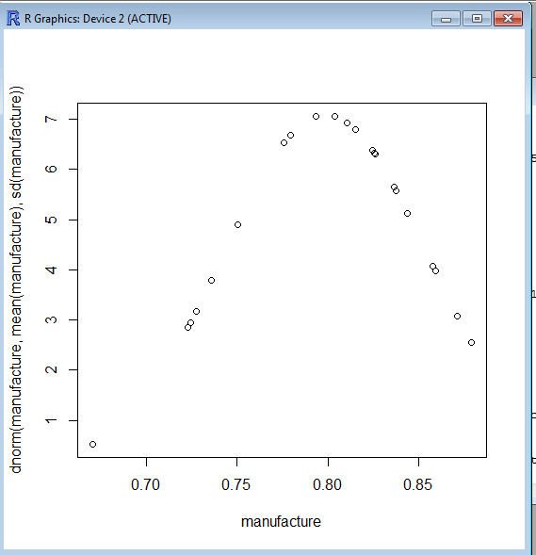

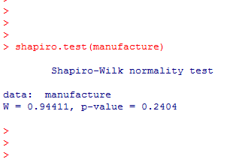

1. Do the data about the industrial production volume by economic activity and the number of employees by economic activity in Kyrgyzstan in 2014 indicate that total volume of production is related to the number of employees?

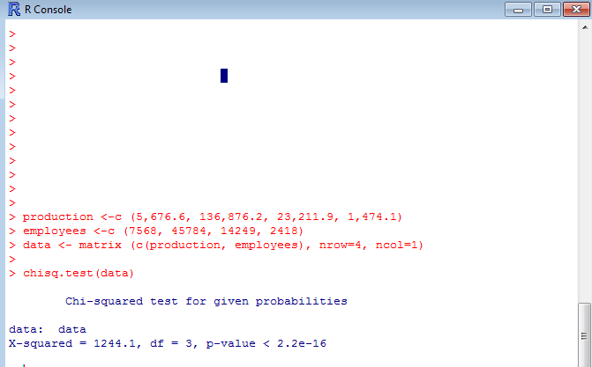

By inserting the code above, we obtain p-value <0.01 that rejects our null hypothesis that states that number of employees and production by economic activity is dependent.